**DAILY ONLINE ACTIVITIES SUMMARY**

|  |  |  |  |  |  |  |  |  |
| --- | --- | --- | --- | --- | --- | --- | --- | --- |
| **Date:** | **20/06/2020** | | | | | **Name:** | **Lavanya D M** | |
| **Sem & Sec** | **4th & ‘A’** | | | | | **USN:** | **4al18cs041** | |
| **Online Test Summary** | | | | | | | | |
| **Subject** | | **D C** | | | | | | |
| **Max. Marks** | | **30** | | **Score** | | | **23** | |
| **Certification Course Summary** | | | | | | | | |
| **Course** | **Creating blog** | | | | | | | |
| **Certificate Provider** | | | **Bitdegree** | | **Duration** | | | **1 week** |
| **Coding Challenges** | | | | | | | | |
| **Problem Statement:1)** Program that compares counting words in files using an ArrayList and a Map  2) Write a C Program to rotate an array by K positions.  3) Write a Java program to count number of bits to be flipped to convert A to B | | | | | | | | |
| **Status: complied** | | | | | | | | |
| **Uploaded the report in GitHub** | | | | | **yes** | | | |
| **If yes Repository name** | | | | | <https://github.com/lavanyamurthi/lockdown-coding> | | | |
| **Uploaded the report in slack** | | | | | **yes** | | | |

Online Test Details: (Attach the snapshot and briefly write the report for the same)

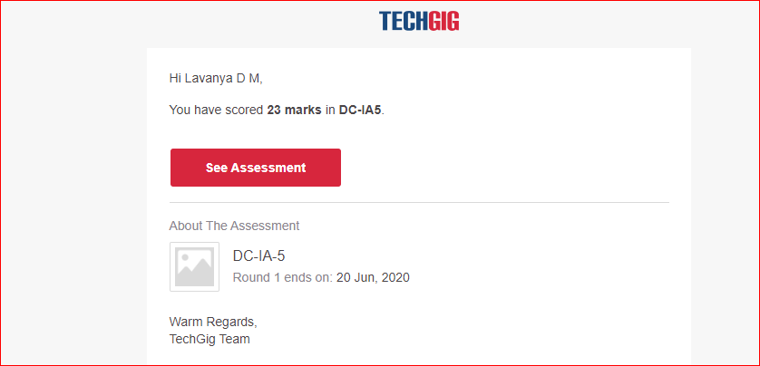

Certification Course Details: (Attach the snapshot and briefly write the report for the same)



Coding Challenges Details: (Attach the snapshot and briefly write the report for the same)

Problem 1: Program that compares counting words in files using an ArrayList and a Map

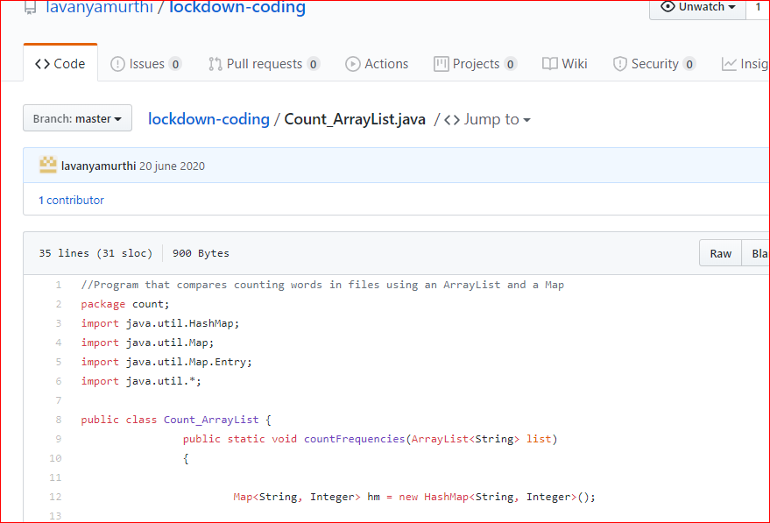

**Problem 2:** Write a C Program to rotate an array by K positions.

Circular array rotation means rotating the elements in the array where one rotation operation moves the last element of the array to the first position and shifts all remaining elements to the right.

For example, consider the following array = [4, 5, 6],  
• Initial array [4, 5, 6]  
• After one rotation [6, 4, 5]  
• After two rotations [5, 6, 4]

OUTPUT

Element at index 0: 5  
Element at index 1: 6  
Element at index 2: 4

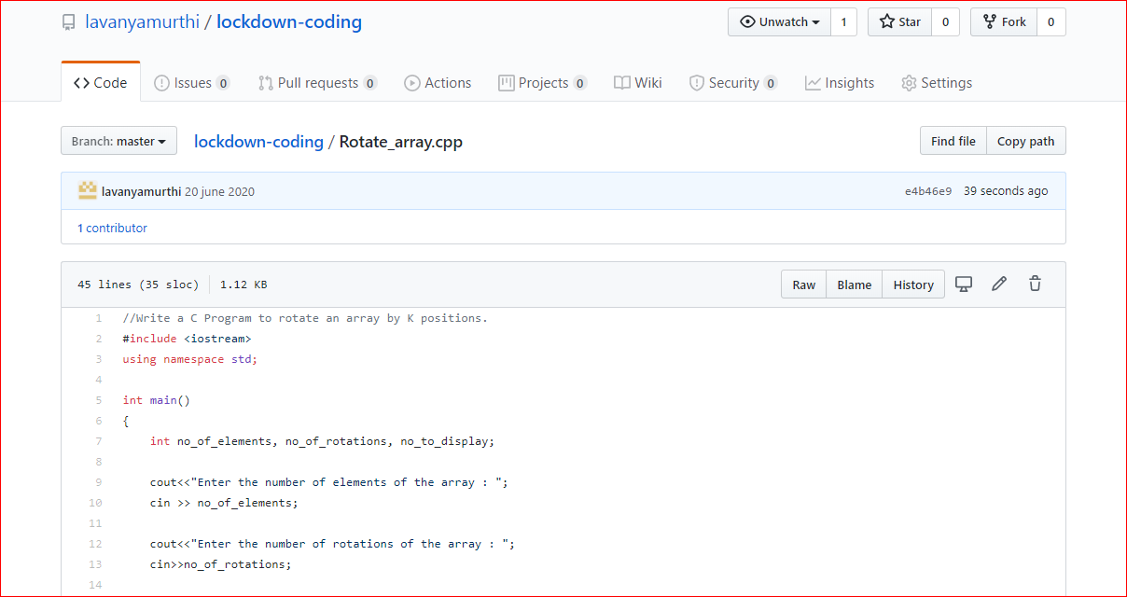

Problem 3: Write a Java program to count number of bits to be flipped to convert A to B

Given two numbers ‘a’ and b’. Write a program to count number of bits needed to be flipped to convert ‘a’ to ‘b’.  
**Example :**

Input : a = 10, b = 20  
Output : 4  
Binary representation of a is 000**0101**0  
Binary representation of b is 00010100  
We need to flip highlighted four bits in a  
to make it b.

Input : a = 7, b = 10  
Output : 3  
Binary representation of a is 0000**01**1**1**  
Binary representation of b is 00001010  
We need to flip highlighted three bits in a  
to make it b.

**Hint**

1. Calculate XOR of A and B.  
   a_xor_b = A ^ B
2. Count the set bits in the above  
   calculated XOR result.  
   countSetBits(a_xor_b)

